Python Variables Worksheet

At its core, programming is all about the management and manipulation of data. This worksheet will focus on declaring and assigning variables as well as conditionals. The purpose is to get the muscle memory of Python syntax down while also understanding the tools better.

**Setup**

* If you haven’t done so already, create a folder called ‘devCodeCamp’ on your desktop. This can be where you put all devCodeCamp projects.
* Inside the devCodeCamp folder, create a folder called ‘PythonIntro’
* Open Visual Studio Code, and select ‘File > Open Folder’ at the top to open the PythonIntro folder. In the Explorer, click the ‘new file button’ and create a file called “worksheet.py”. Applying the correct extension to the file name (.py) will create this file asa Python file.
* 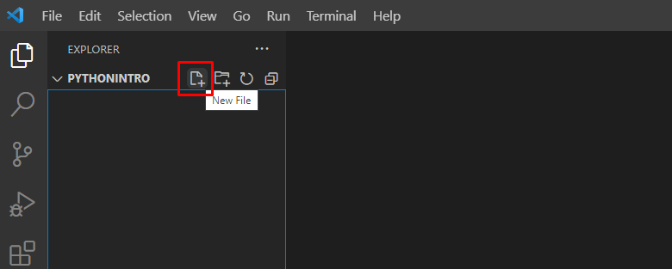
* What a successful version looks like:
* 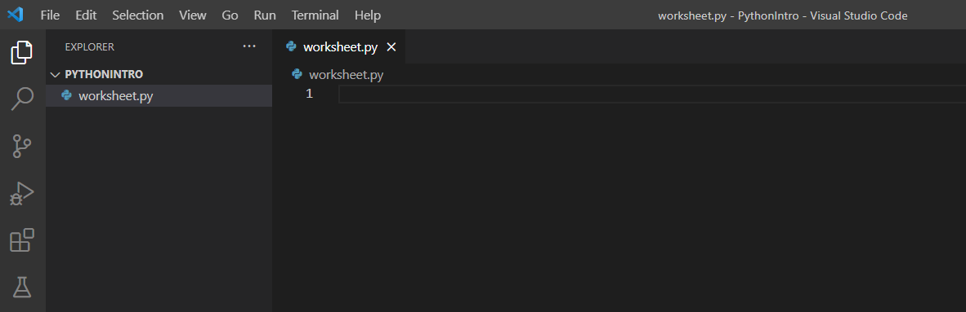

*The definition of ***hard-code***is thepart of a program that cannot be altered in any way. For example, “it is 37 degrees outside”. The way to avoid this is to substitute the hard-coded value for a variable, because variables open the door for your program to have updated values.

**Variables**

1. Age
   1. Declare a variable and store your age in that variable.
   2. Use string interpolation to format a message to the console utilizing the previously declared variable. **Print to the console “I am XX years old”**, where XX represents the value of your age. You cannot *hard-code the value of your age in the string.
2. First Name
   1. Declare a variable to store the string value of your first name.
   2. Use the built-in Python *input()* function to retrieve the first name value via user input.
      1. The *input ()* function allows a user to input a value before executing the next line of code. After inputting a value and pressing 'enter’, the value will be returned to wherever the *input()* function was called.
3. Last Name
   1. Declare a variable to store the string value of your last name.
   2. Use the built-in Python *input()* function to retrieve the last name value via user input.
4. Full Name
   1. Use string concatenation to take the value stored in your first name variable (Question 2) and the value stored in your last name variable (Question 3) and “combine” them together to be stored in a new variable.
      1. Example expected out: “Michael Terrill”
   2. Use string interpolation to format a message to the console utilizing the previously declared variables. **Print to the console “My first name is FF and my last name is LL, which means my full name is FN”**, where FF represents your first name value, LL represents your last name value, and FN represents the concatenated full name value. You cannot hard-code the values in the string.
      1. Example expected output: **“My first name is Michael and my last name is Terrill, which means my full name is Michael Terrill”**
5. Temperature Converter
   1. Declare a variable to store a Fahrenheit temperature.
   2. Convert the stored Fahrenheit temperature to Celsius and store the converted temperature in a variable.
      1. Research is a big part of being a developer. A good search term to use: “Fahrenheit to Celsius formula”.
      2. The reason this is a good search term for your research is because it will give you the formula you need to put in your code to achieve your goal, opposed to doing the conversion for you.
   3. **Print to the console “FF degrees Fahrenheit is CC degrees Celsius”**,where FF represents the degrees in Fahrenheit and CC represents the degrees in Celsius.You cannot hard-code the values in the string.